***Design and Analysis of Algorithm Lab***

***LABORATORY FILE***

***Submitted by:***

***Prakhar Shrivastava***

***SAP ID: 500107776***

***Batch: 9***

***B.Tech Computer Science and Engineering***

***Specialization AIML***

***3rd Semester***

***Submitted to:***

***Amar Jindal***

**EXPERIMENT 1: Title: BRUTE FORCE TECHNIQUES**

1. Sort a given set of elements using bubble and selection sort and hence find the time required to sort elements.

**Bubble Sort:**

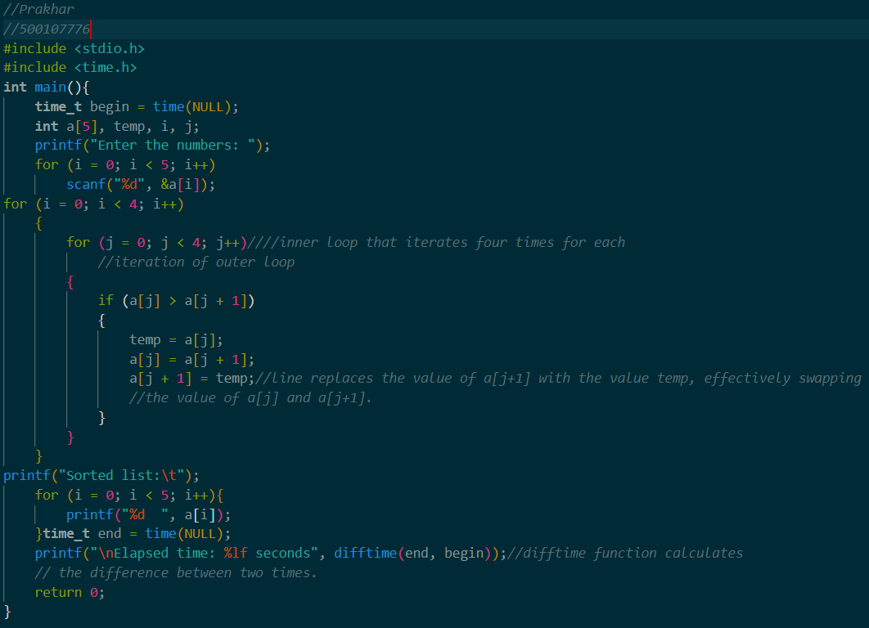

**Output:**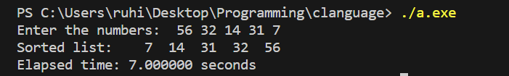

**Selection Sort:**

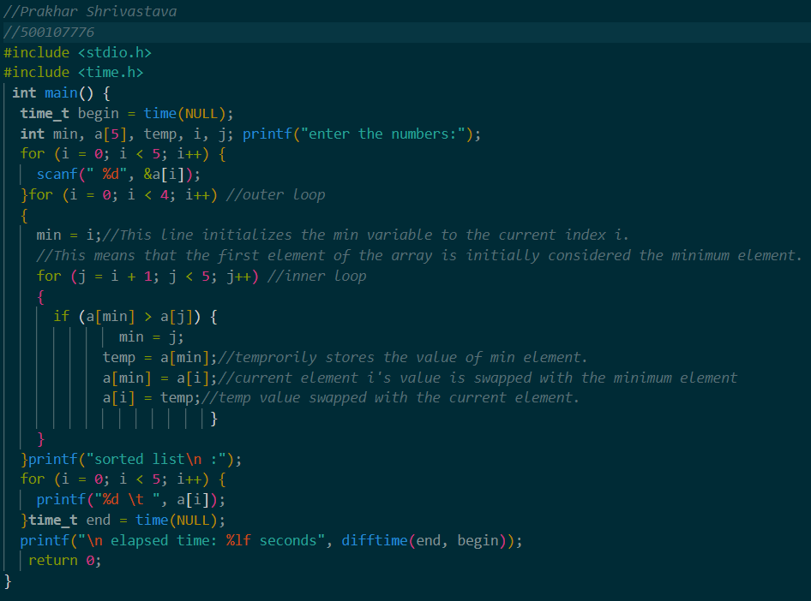

**Output:**

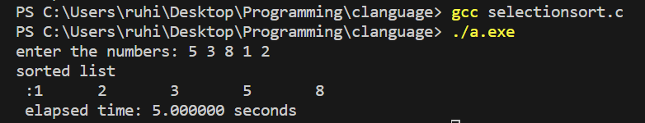2.Perform linear search and find the time required to search an element.

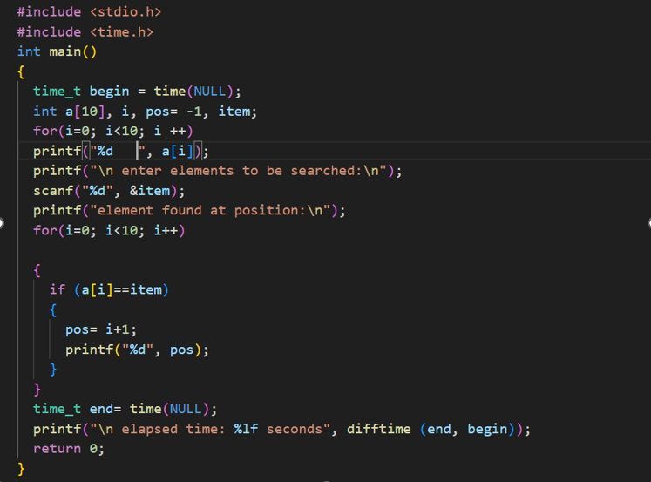

**Output:**

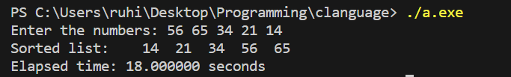3.Given a string called TEXT with ‘n’ characters and another string called PATTERN with ‘m’ characters (m<=n). Write a program which implements brute force string matching to search for a given pattern in the text. If the pattern is present then find the position of first occurrences of Pattern in that Text.

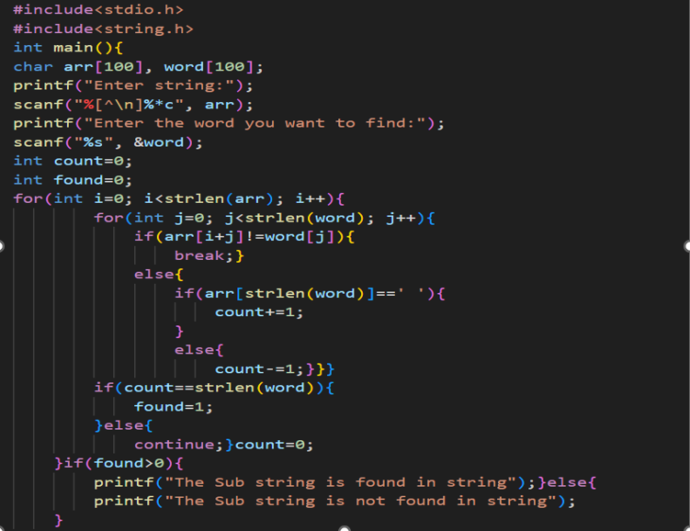

**Output:**

